Friday 8th November 2024

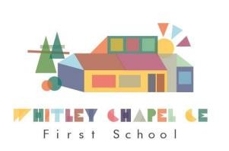

Whitley Chapel C of E First School

Dear Parents,

We have had another lovely week in school and we are fast approaching our Christmas season!

**CHILDREN IN NEED BREAKFAST**

**On Friday 15th November it is Children In Need so we are hosting a Breakfast for families. Come along between 8.30am and 9.30am!**

**Mrs Kellett has previously sent out details. We would love to see you all! … Please let us know if you would like to come along!**

Come along and have fun at the Ceilidh ...







The children will be beginning to practise for our Christmas Performance on Wednesday next week!

**Christmas Events ...**

**Thursday 12th December 3pm – Christmas Fair**

**Tuesday 17th December 6pm-7pm Christmas Performance**

**Thursday 19th December – Christmas Jumper and Lunch also Afternoon party for the**

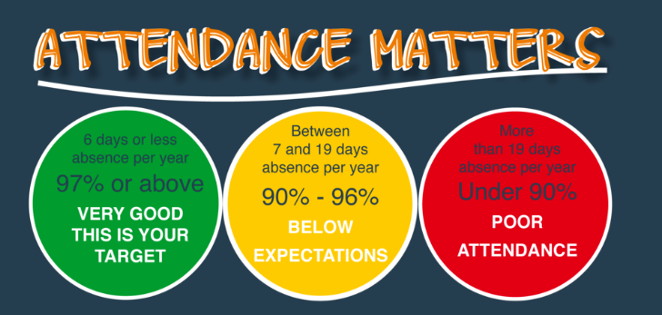

Come to School every day!

On **Saturday 30th November**, we will be hosting an Early Years Open Morning for prospective Parents. Please tell everyone who you think may be interested!

Have a lovely weekend everyone, see you on Monday!

Mrs Hayward 😊

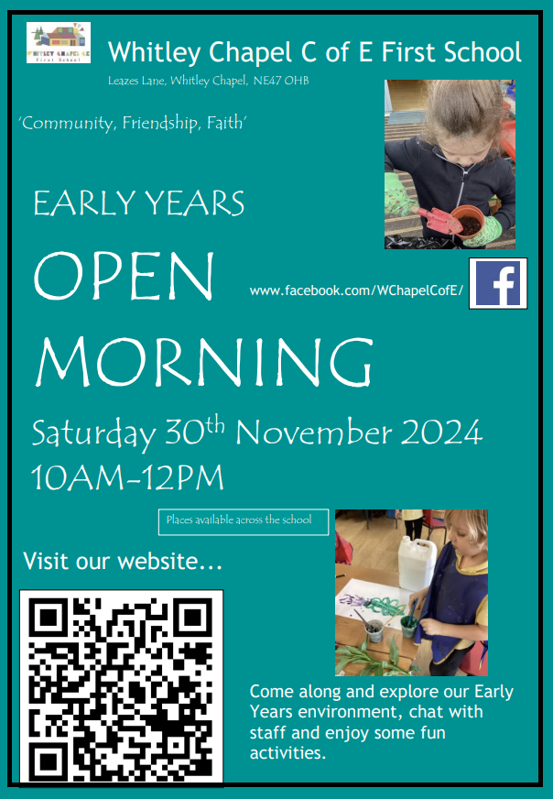

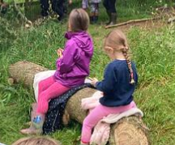

**Forest School**

Forest School is coming …

**Wednesday 20th November** - Early Years and class One

**Wednesday 27th November** – Class Two

**CLUBS**

**(3.30pm – 4.30pm)**

Mondays- Messy Church Club

Tuesdays - Multi skills Club

Wednesdays - Dance with Pip

Thursdays – Christmas Cookery club

**PARENTS EVENING**

Parents meetings are being held this week. All Parents/Carers should have their appointment dates and times but if not please just drop up a message.